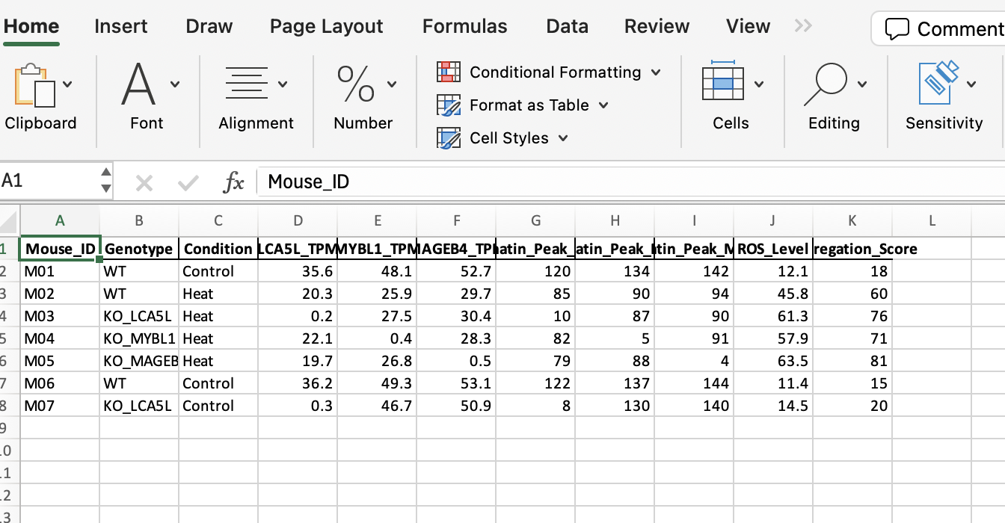Data Generated from ChatGpt

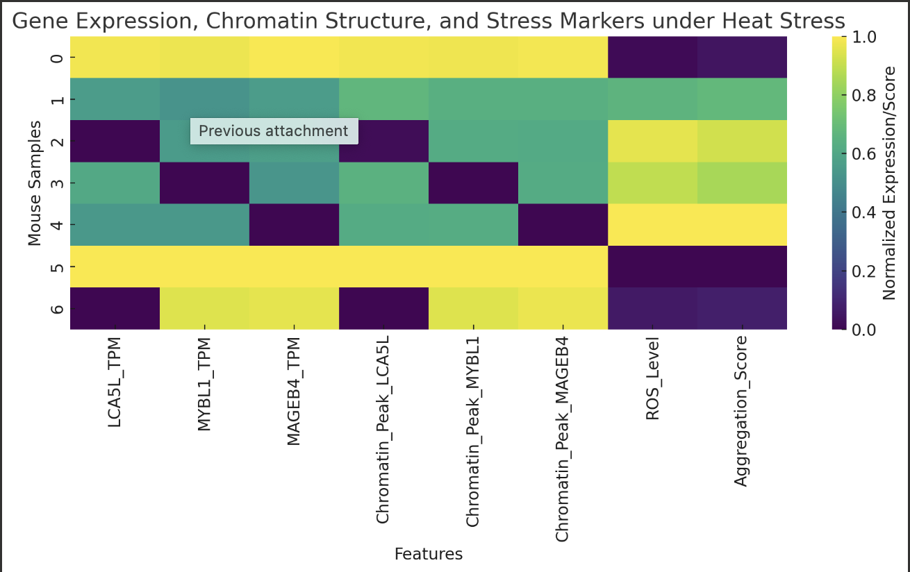Graph that was Generated

install.packages("readxl")

install.packages("pheatmap")

# Load necessary libraries

library(readxl)

library(pheatmap)

# Load the data

data <- read_excel("Heat_Stress_Spermatogenesis_Data.xlsx")

# Select relevant columns for heatmap

heatmap_data <- data[, c("LCA5L_TPM", "MYBL1_TPM", "MAGEB4_TPM",

"Chromatin_Peak_LCA5L", "Chromatin_Peak_MYBL1", "Chromatin_Peak_MAGEB4",

"ROS_Level", "Aggregation_Score")]

# Normalize data (min-max scaling)

normalize <- function(x) {(x - min(x)) / (max(x) - min(x))}

normalized_data <- as.data.frame(lapply(heatmap_data, normalize))

# Set row names to Mouse_ID or Genotype for easier interpretation

rownames(normalized_data) <- paste(data$Mouse_ID, data$Genotype, data$Condition, sep = "_")

# Create the heatmap

pheatmap(normalized_data,

cluster_rows = TRUE,

cluster_cols = TRUE,

color = colorRampPalette(c("navy", "white", "firebrick3"))(50),

main = "Heatmap: Gene Expression, Chromatin State, and Stress Markers")

Code Ran